POC-1: STATIC WEBSITE DEPLOYMENT
End-to-End CI/CD Pipeline Project Report
GitHub • GitHub Actions • Jenkins • Docker • Docker Hub • Kubernetes • NGINX

Prepared by: Nivedha P M
Date: August 2026

Executive Summary
POC-1 builds a complete, end-to-end CI/CD pipeline for a simple HTML/CSS static website. The website itself isn't the point — the automation chain around it is:
- Goal: a single developer push results in an automatically updated, publicly accessible website, with no manual step at any stage.
- Approach: every change built on its own Git feature branch, reviewed via Pull Request, merged into main, and verified before the next phase was layered on top.
Result: push to GitHub → GitHub Actions notifies Jenkins → Jenkins builds, publishes to Docker Hub, deploys to Kubernetes, waits for rollout, verifies → site is live on the public internet. Zero manual steps.

Key Outcomes
- Fully automated CI/CD pipeline: push → build → publish → deploy → verify.
- Production-style Kubernetes deployment (Namespace, Deployment with 2 replicas, Service, Ingress) on a self-managed Minikube cluster.
- Disciplined Git workflow: 9 feature branches, 9 PR merges, zero direct commits to main.
- Public internet access via the VM's public IP, resolved through a real multi-hop networking investigation.
- Complete phase-by-phase documentation with screenshot evidence.

1. Project Overview & Requirements

1.1 Manager's Requirement
"Design and implement an end-to-end CI/CD pipeline for a simple HTML/CSS static website. Store the source code in GitHub, use GitHub Actions to validate the files, use Jenkins to build an NGINX-based Docker image, push the image to a container registry, and deploy it to Kubernetes. Access the website through a Kubernetes Service and document the complete workflow."
- The underlying DevOps platform (Git, Docker, Jenkins, Kubernetes, GitHub Actions) already existed as a separate exercise.
- This POC focused entirely on using that platform to deliver a working pipeline, not on infrastructure setup.

1.2 Requirement Analysis

Functional Requirements
- The manager's brief specifies only “a simple HTML/CSS static website” — it does not prescribe page content or sections.
- The Home / About / Services / Contact structure, the “DevOps Solutions” theme, and all page content were my own design decision, made to give the site enough substance to meaningfully demonstrate the pipeline without turning it into a frontend exercise.
- This is a DevOps exercise that happens to deploy a website, not a frontend exercise — effort was deliberately kept light on the application itself.

Non-Functional Requirements
- Demonstrate practical, working use of: Git, GitHub, GitHub Actions, Jenkins, Docker, Docker Hub, Kubernetes, NGINX.

Deliverables
- A GitHub repository with a disciplined branch and PR history
- A Jenkins pipeline (declarative Jenkinsfile)
- A Docker image, built from an NGINX base
- A Docker Hub repository holding published, versioned images
- A Kubernetes Deployment and Service
- A running, publicly browser-accessible website
- Complete documentation of the workflow, with evidence

1.3 Success Criteria
- The full chain had to run end to end, without manual intervention at any stage.
- A Docker image that builds but is never deployed would not count as success.

Developer Push
↓
GitHub
↓
GitHub Actions
↓
Jenkins
↓
Docker Build
↓
Docker Push
↓
Kubernetes Deployment
↓
Website Opens Successfully

1.4 Technology Stack
Component | Technology
Website | HTML + CSS
Web Server | NGINX
Source Control | Git
Repository | GitHub
Continuous Integration | GitHub Actions
Continuous Delivery | Jenkins
Container Runtime | Docker
Registry | Docker Hub
Orchestration | Kubernetes (Minikube)
Public Exposure | NGINX Ingress + host-level NGINX reverse proxy

1.5 Repository & Branching Strategy
- Repository devops-poc-01 — folder structure planned up front, but only scaffolded as needed.
- Files like the Dockerfile and Kubernetes manifests were added only in the phase that implemented them — no empty placeholders.
- Every feature: branch → Pull Request → merge into main. Never a direct commit to main.
All feature work branches off main and merges back into it, in this sequence:
- main
  - feature/project-setup → Pull Request → Merge
  - feature/application → Pull Request → Merge
  - feature/docker → Pull Request → Merge
  - feature/kubernetes → Pull Request → Merge
  - feature/cicd-deployment → Pull Request → Merge
  - ... (Ingress / public access) → Pull Request → Merge

2. Architecture & Design

2.1 Overall Pipeline Architecture
- A single, linear delivery chain — each stage exists specifically to remove a manual step from the one before it.
Developer — Git Feature Branch — Pull Request — Merge to main
↓
GitHub Repository
↓
GitHub Actions (validation + Jenkins trigger)
↓
Jenkins (checkout, build, tag, push, deploy, verify)
↓
Docker Hub (versioned image registry)
↓
Kubernetes / Minikube (Namespace, Deployment, Service)
↓
NGINX Ingress → Host NGINX Reverse Proxy → Public Internet

2.2 Key Design Decisions
Decision | Rationale
Simple static site | Keeps effort weighted toward the DevOps lifecycle (~80%) rather than frontend work (~20%).
Git feature branches + PRs | Forces a review point before code reaches main; every change stays isolated and revertible.
GitHub Actions AND Jenkins | Actions handles lightweight validation and triggers Jenkins; Jenkins owns the heavier build/deploy work.
NGINX-based Docker image | Explicitly required by spec; also lightweight, fast, industry standard for static content.
Docker Hub as registry | Free, widely used, no extra infrastructure, integrates directly with Kubernetes' image pull.
Two-tag versioning ('latest' + build #) | 'latest' alone can't distinguish builds; the build tag gives traceability and a rollback target.
Namespace before anything else | Every other resource (Deployment, Service, Ingress) is scoped under it — isolates this POC on a shared cluster.
2 replicas, not 1 | One replica proves nothing about self-healing or rolling updates; 2 is the minimum that shows both.
Fixed NodePort before Ingress | Minikube can reassign a random NodePort on restart; a fixed port kept early verification stable.
kubectl direct from Jenkins host (not SSH/plugin) | Jenkins, Docker, and kubectl already share the VM — a local call skips an unneeded credential and network hop.
Ingress + host reverse proxy for public access | A NodePort isn't a public entry point; this combo gives a stable HTTP entry at the VM's public IP.

2.3 Target Runtime Architecture
Internet
↓
OCI VM Public IP (port 80)
↓
Host-level NGINX Reverse Proxy
↓
Minikube Container (Docker driver)
↓
NGINX Ingress Controller
↓
Kubernetes Service (poc1 namespace)
↓
Deployment (2 replicas) → Pods running the nivedhapm/poc1 image

3. Implementation Walkthrough
Each phase below: what was done, key commands/config, outcome, and screenshot evidence.

3.1 Repository Initialization
- Created the GitHub repository, first feature branch, and professional folder structure.
- Carried the change through its first Pull Request and merge.
- Established a discipline repeated for the rest of the project: verify GitHub Actions and Jenkins both react correctly after every merge — a merge isn't “done” until automation has reacted to it.
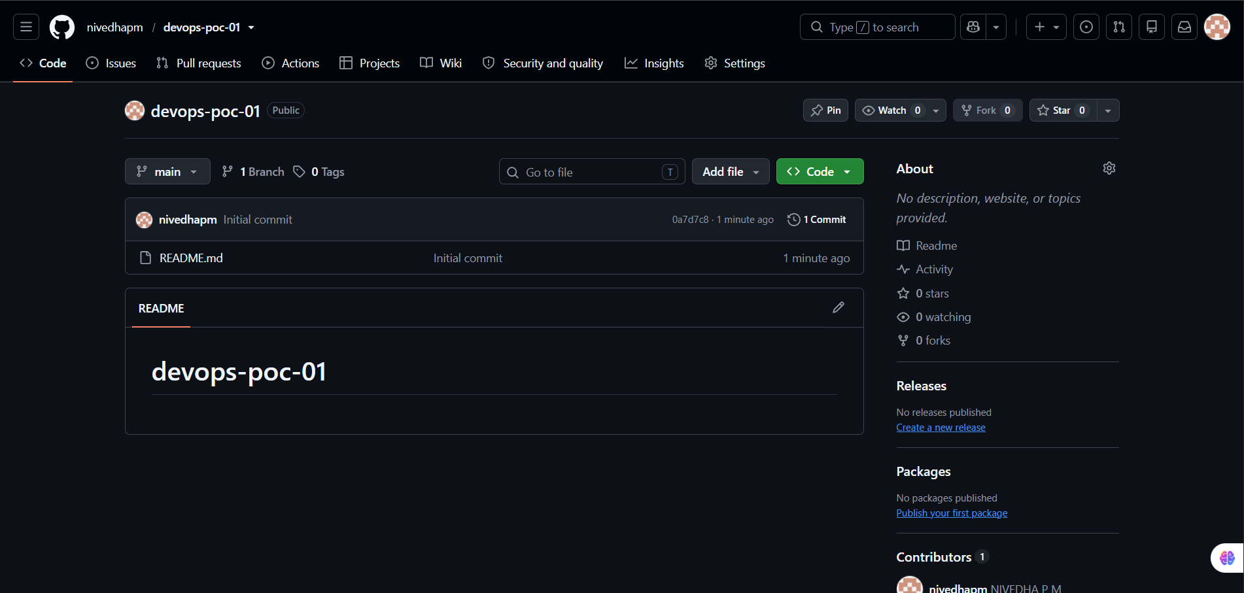
Figure 3.1.1 — The devops-poc-01 repository created on GitHub, initial commit.
- Verified local clone was clean, then created feature/project-setup — no development directly on main.
- Scaffolded the planned folder structure (docker/, kubernetes/, website/, docs/, .github/workflows/).
- Staged, committed, pushed, and opened a Pull Request for review before merging into main.
git checkout -b feature/project-setup
git add . && git commit -m "Initialize project structure for POC-1"
git push -u origin feature/project-setup
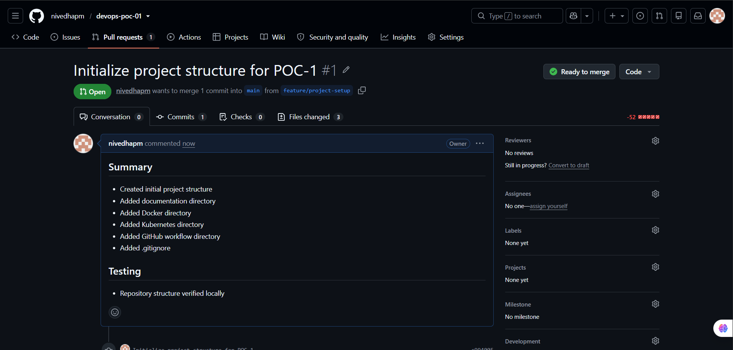
Figure 3.1.2 — Pull Request #1, “Initialize project structure for POC-1,” reviewed and merged.
- After merge: synced local main and deleted the now-obsolete feature branch, both locally and remotely — repeated after every feature for the rest of the project.
- Confirmed repo state clean, with ci.yml and Jenkinsfile in place for the phases that follow.
git checkout main && git pull origin main && git branch -d feature/project-setup
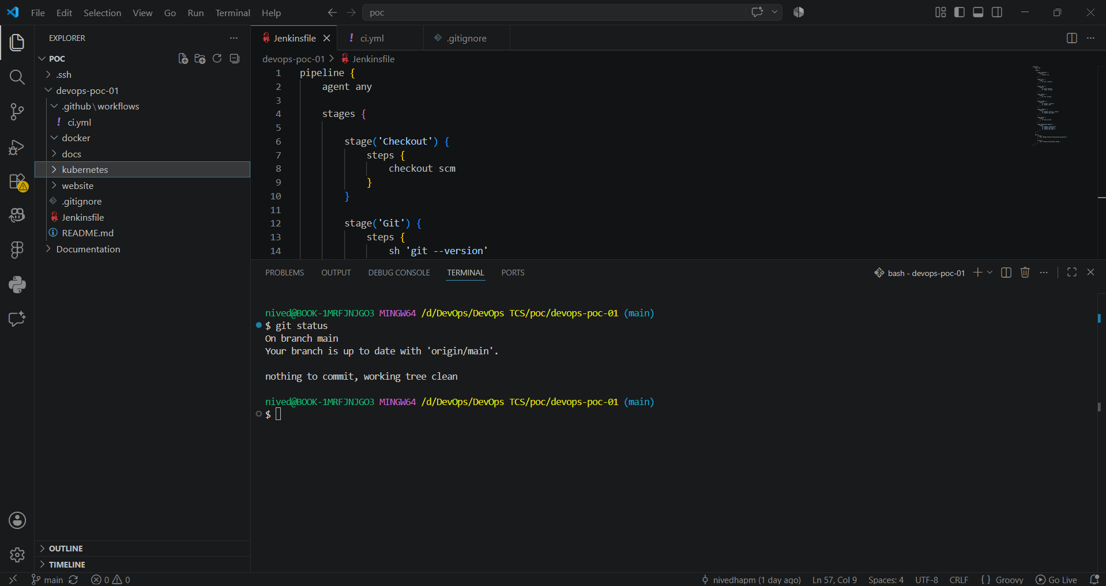
Figure 3.1.3 — Clean working tree on main after the first merge, with ci.yml and Jenkinsfile in place.

3.2 Application Development
- Built the application: a simple static website styled as a fictional company, “DevOps Solutions,” with Home, About, Services, and Contact sections — a page structure and theme chosen personally, since the manager's brief only specified “a simple HTML/CSS static website.”
- Hero headline “Automating Software Delivery” plus four service cards: Git & GitHub, Docker, Jenkins, Kubernetes.
- Effort deliberately weighted ~20% application / ~80% DevOps lifecycle — the site only needed to be good enough to demonstrate the pipeline.
- Plain HTML and CSS, no external frameworks — keeps the artifact easy to containerize.
- Workflow: sync main → branch (feature/application) → build → verify locally in browser → commit.
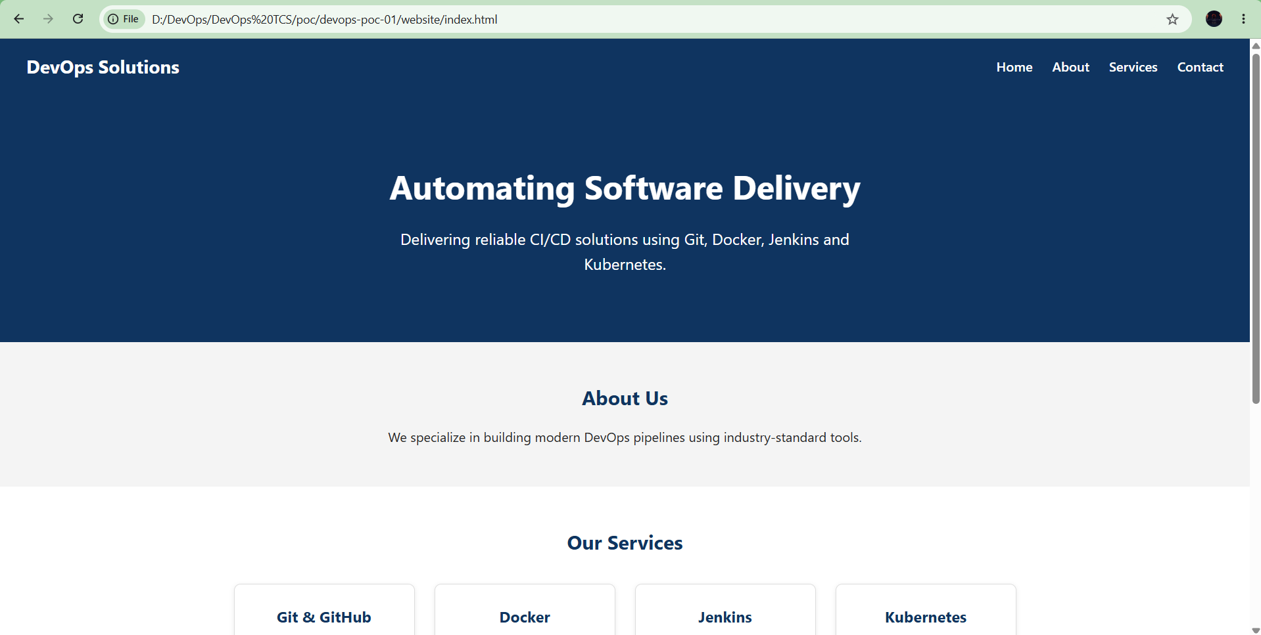
Figure 3.2.1 — The DevOps Solutions static site running locally, verified before commit.
git add website/
git commit -m "Add website application development code for POC-01"
git push -u origin feature/application
- Reviewed through Pull Request #2, merged into main, and branch cleaned up — same pattern as Phase B.
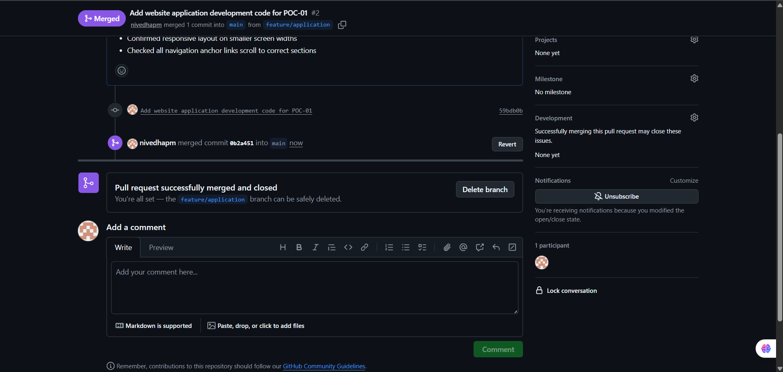
Figure 3.2.2 — Pull Request #2 merged into main; feature branch ready for deletion.

3.3 Containerization (Docker + NGINX)
- Until now the browser opened index.html directly from disk — real deployments never do this; a web server has to sit in front of the files.
- Converted the verified website into a portable, deployable Docker image, on branch feature/docker.
- NGINX-based image explicitly required by spec, and a natural fit anyway: lightweight, fast, industry standard for static content.
- Three config files: Dockerfile (build recipe), custom nginx.conf, .dockerignore (clean build context).
- Dockerfile: starts from nginx:alpine, removes the default NGINX site, copies in the static site + custom config, exposes port 80, runs NGINX in the foreground.
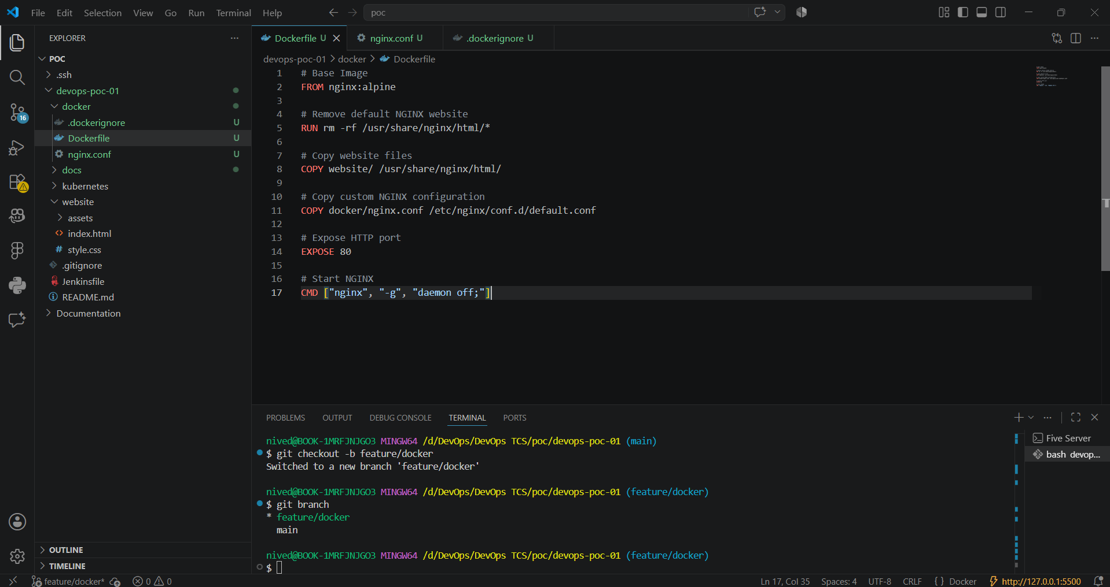
Figure 3.3.1 — The Dockerfile: FROM nginx:alpine, copy the website into the image, replace the default NGINX config, expose port 80.
- Built and ran the image manually to verify it before wiring into Jenkins:
docker build -t devops-poc-01:build-001 -f docker/Dockerfile .
docker run -d --name devops-poc-01 -p 8081:80 devops-poc-01:build-001
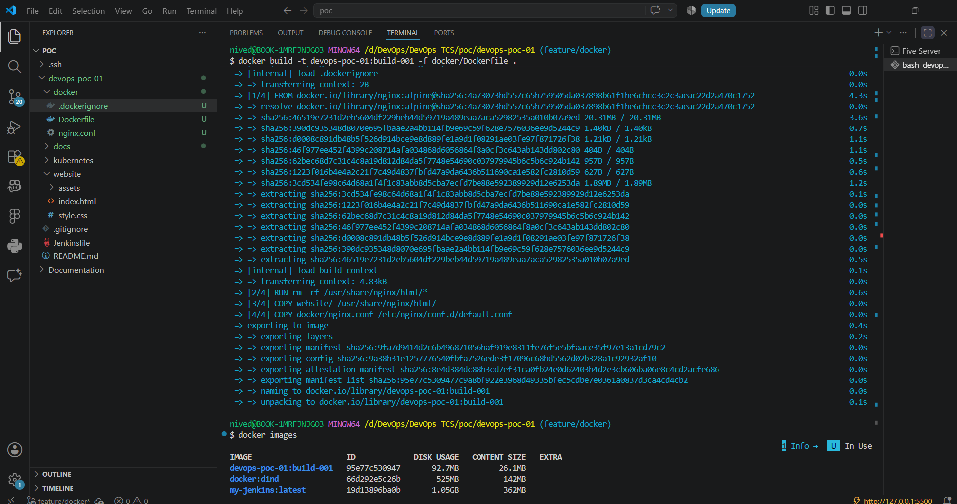
Figure 3.3.2 — Docker build output and the resulting image, built from the Dockerfile and .dockerignore.
- Container logs confirmed NGINX started cleanly and served /, /style.css, /favicon.ico.
- Site confirmed live in the browser through the mapped port.
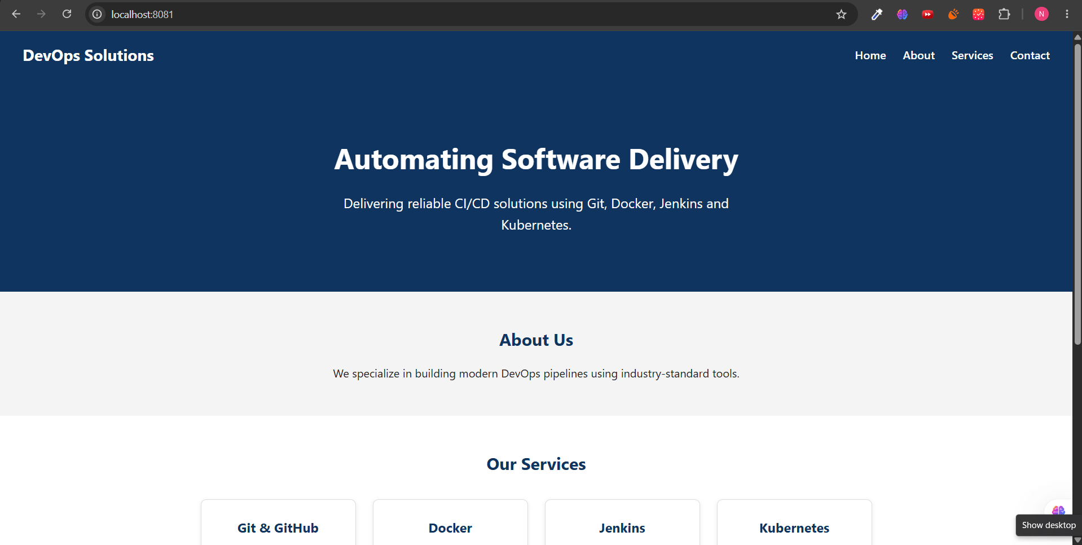
Figure 3.3.3 — The website served from inside the Docker container at localhost:8081.
- Committed, pushed, reviewed via Pull Request #3, and merged into main — same branch-cleanup discipline as every prior feature.
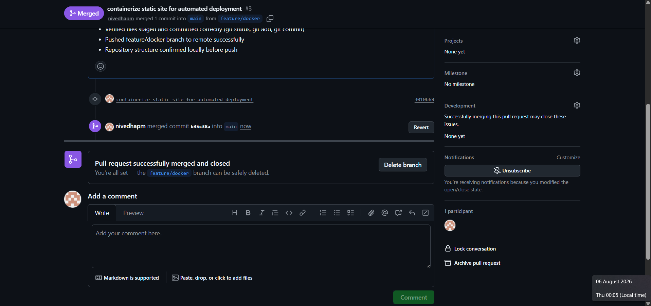
Figure 3.3.4 — Pull Request #3, containerization, merged into main.

3.4 Continuous Integration with Jenkins
- Replaced the manual docker build / docker run steps with an automated Jenkins pipeline.
- Required host prep first: Java (Jenkins' runtime), Jenkins itself, and Docker access for the Jenkins service account.
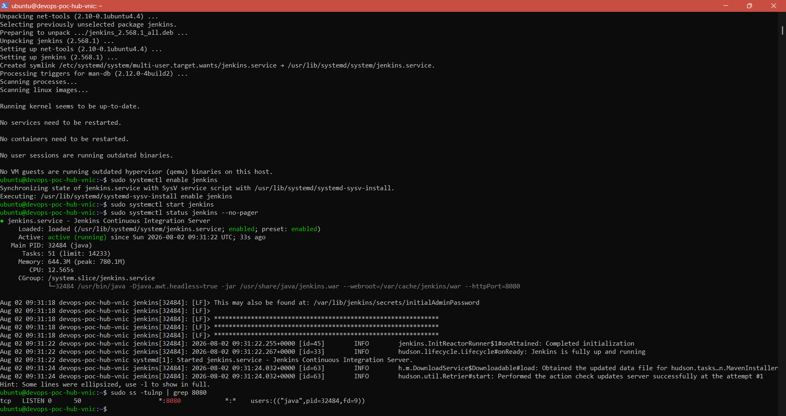
Figure 3.4.1 — Jenkins installed and running as a systemd service on port 8080, after Java and Docker were prepared on the same host.
- Jenkins needed read access to GitHub and permission to talk to the Docker daemon.
- Added an SSH deploy key on GitHub, registered a matching credential in Jenkins.
- Added the Jenkins user to the docker group so pipeline stages could call docker directly.
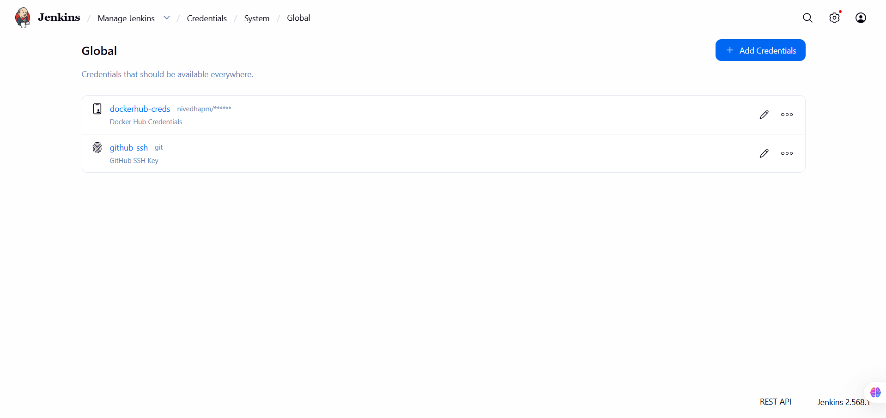
Figure 3.4.2 — SSH and Docker Hub credentials registered in Jenkins' credential store.
- Created a Pipeline job (not Freestyle), backed by the Jenkinsfile in source control.
- Stages: checkout repository, verify project/website file structure, build Docker image.
- GitHub Actions validates pushed files and triggers Jenkins via webhook.
- Pipeline ran successfully across successive automated builds, one per merged feature.
Here’s the complete Jenkinsfile pipeline:
pipeline {

agent any

environment {
IMAGE_NAME = "devops-poc-01"
IMAGE_TAG = "build-${BUILD_NUMBER}"
}

stages {

stage('Checkout Source') {
steps {
checkout scm
}
}

stage('Verify Project Structure') {
steps {
sh '''
echo "Checking project structure..."
ls -R
'''
}
}

stage('Verify Website Files') {
steps {
sh '''
test -f website/index.html
test -f website/style.css
echo "Website files verified."
'''
}
}

stage('Build Docker Image') {
steps {
sh '''
docker build \
-t nivedhapm/poc1:latest \
-t nivedhapm/poc1:build-${BUILD_NUMBER} \
-f docker/Dockerfile .
'''
}
}

stage('List Docker Images') {
steps {
sh '''
docker images
'''
}
}

stage('Push Image to Docker Hub') {
steps {
withCredentials([
usernamePassword(
credentialsId: 'dockerhub-creds',
usernameVariable: 'DOCKER_USER',
passwordVariable: 'DOCKER_PASS'
)
]) {

sh '''
echo "$DOCKER_PASS" | docker login -u "$DOCKER_USER" --password-stdin

docker push nivedhapm/poc1:latest

docker push nivedhapm/poc1:build-${BUILD_NUMBER}

docker logout
'''
}
}
}

stage('Deploy to Kubernetes') {
steps {
sh '''
echo "Deploying application to Kubernetes..."

kubectl apply -f kubernetes/namespace.yaml

kubectl apply -f kubernetes/deployment.yaml

kubectl apply -f kubernetes/service.yaml

kubectl set image deployment/poc1-deployment \
website=nivedhapm/poc1:build-${BUILD_NUMBER} \
-n poc1
'''
}
}

stage('Wait for Rollout') {
steps {
sh '''
echo "Waiting for deployment rollout..."

kubectl rollout status deployment/poc1-deployment -n poc1
'''
}
}

stage('Verify Deployment') {
steps {
sh '''
echo "Verifying deployed Pods..."

kubectl get pods -n poc1

kubectl get svc -n poc1
'''
}
}

}

post {

success {
echo 'Pipeline completed successfully.'
}

failure {
echo 'Pipeline failed.'
}

}

}

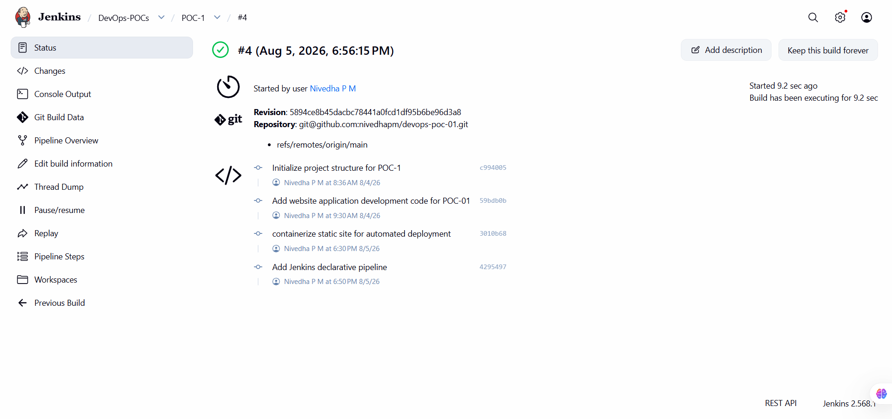
Figure 3.4.3 — Jenkins build history showing successive automated builds, one per merged feature branch.

3.5 Docker Hub Integration
- Until now, Jenkins built the image and stopped — it only existed on the Jenkins host.
- Published the image to Docker Hub so any machine (including the Kubernetes cluster) could pull the exact image Jenkins built.
- This is the point the pipeline stopped being just “CI” and became “CD”: a validated artifact leaves the build server and becomes deployable.
- Created repository nivedhapm/poc1 on Docker Hub.
- Generated a Docker Hub Personal Access Token, stored as a managed Credential in Jenkins — never hardcoded in the Jenkinsfile.
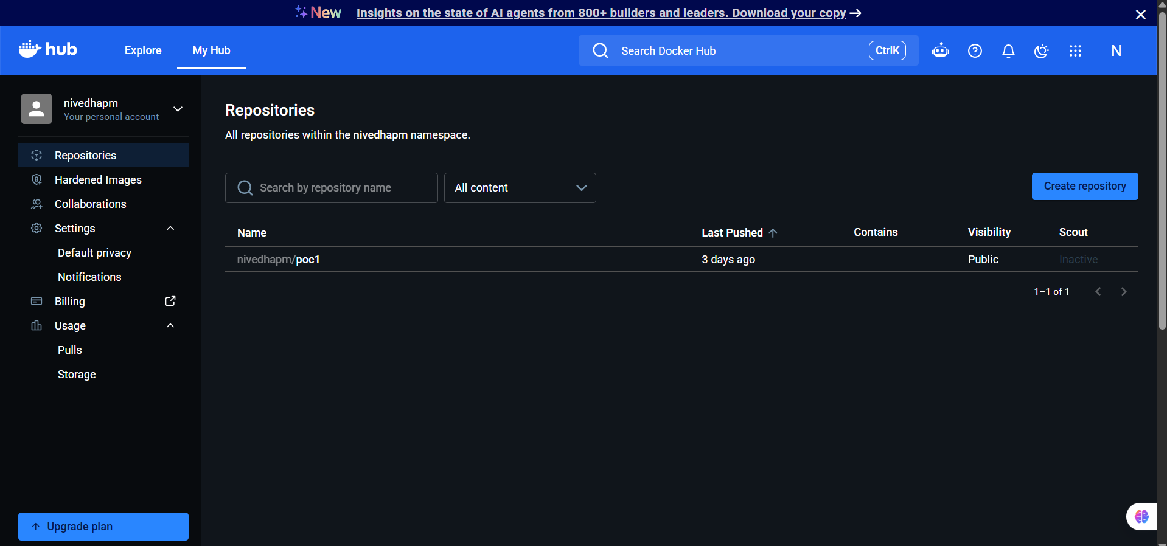
Figure 3.5.1 — The nivedhapm/poc1 repository created on Docker Hub.
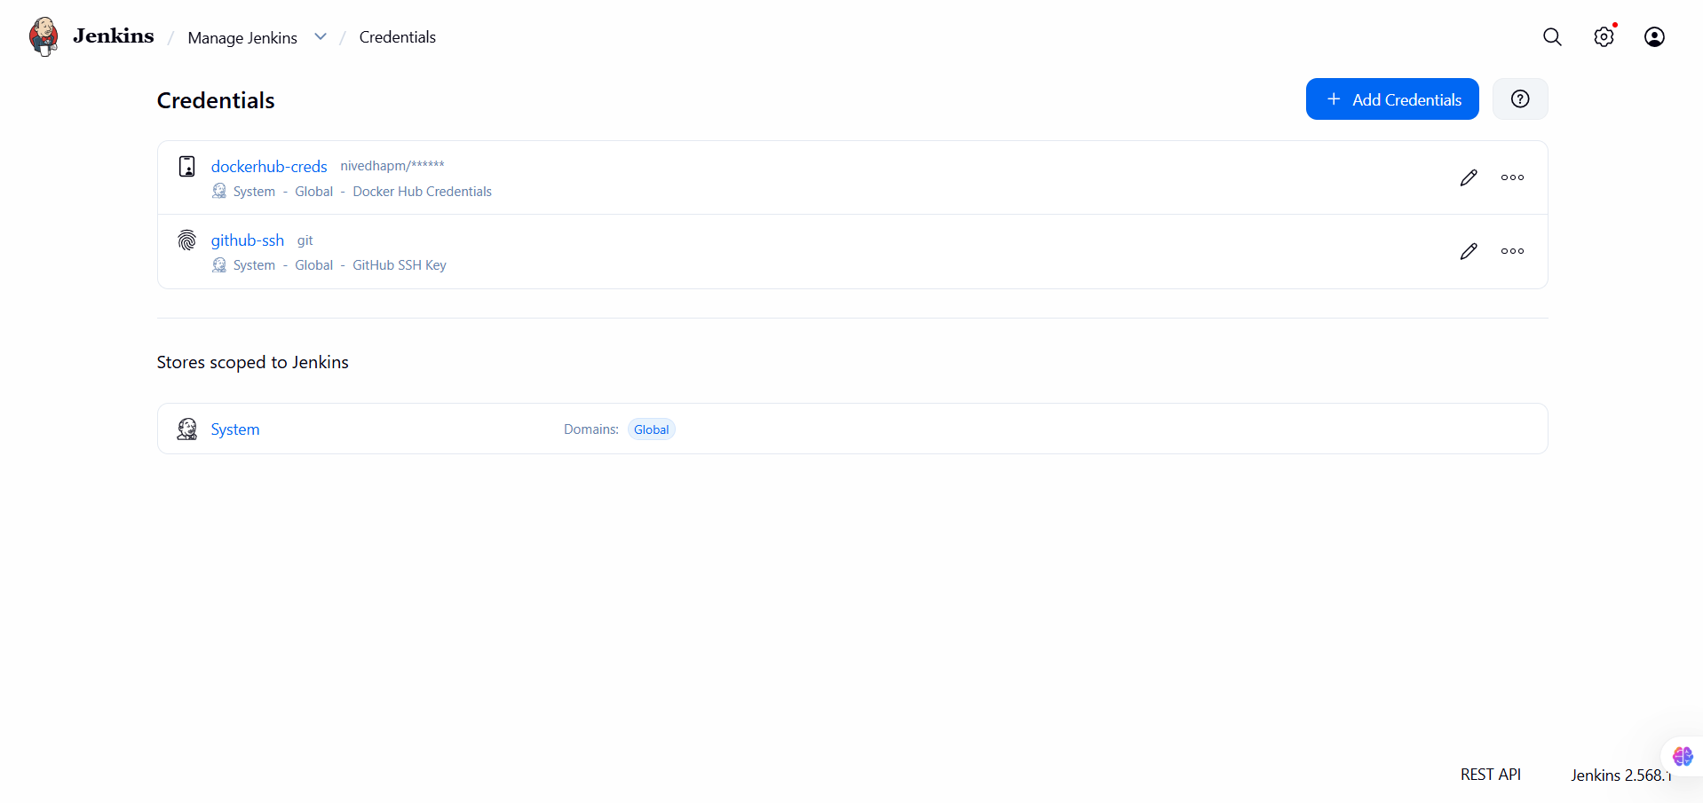
Figure 3.5.2 — Docker Hub token stored as a Jenkins credential (dockerhub-creds), never exposed in pipeline source.
- Extended the Jenkinsfile: build → tag → authenticate → push → logout.
- Two-tag versioning: 'latest' for convenience, a build-numbered tag for traceability and rollback.
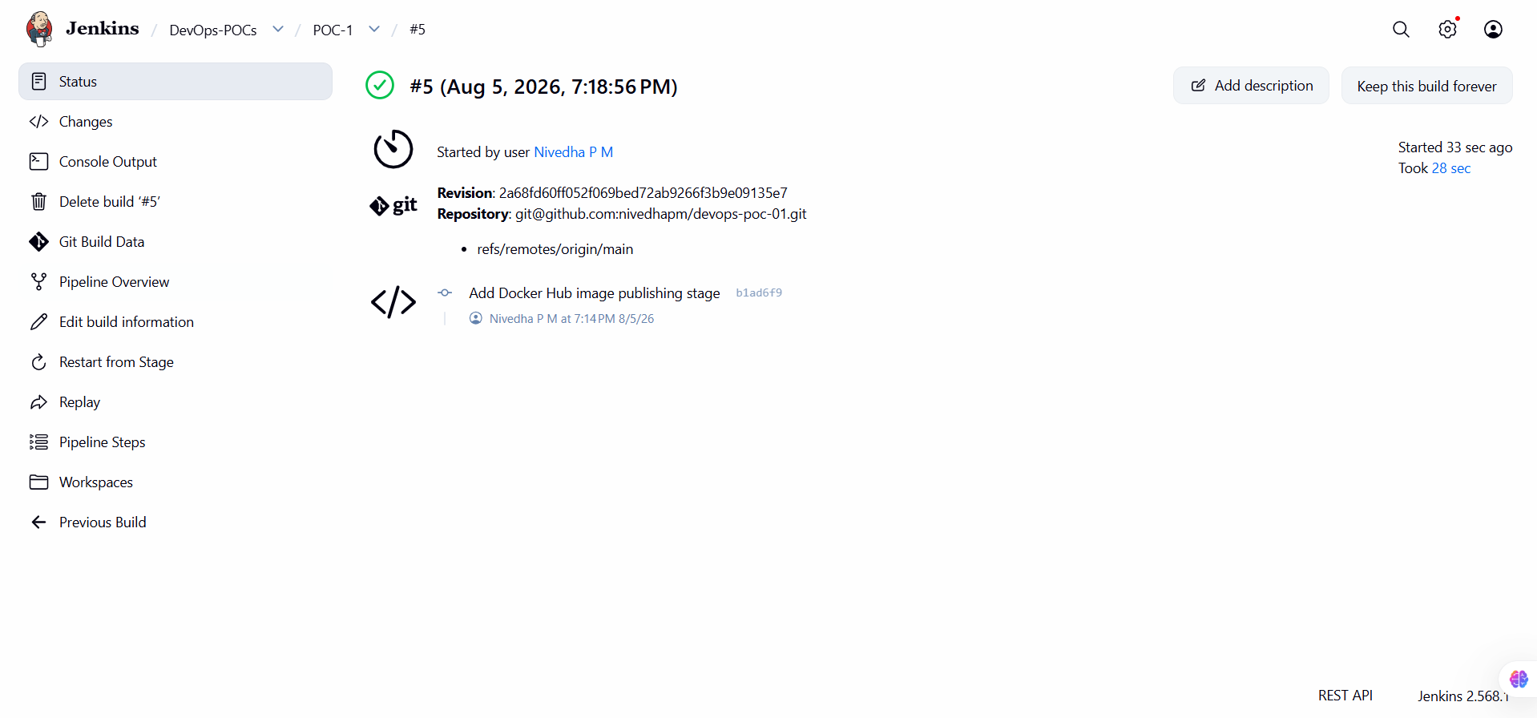
Figure 3.5.3 — Jenkins build history showing the pipeline extended with the Docker Hub publishing stage.

3.6 Kubernetes Deployment
- Moved the application from a single docker run container to a Kubernetes-managed workload on a Minikube cluster (same VM).
- Layered resources deliberately: Namespace first (isolates this POC on a shared cluster), then Deployment with 2 replicas (enough to demonstrate self-healing and rolling updates), then a NodePort Service.
- Installed, started, and confirmed the Minikube cluster healthy before writing any manifests — node Ready, all system pods Running.
minikube start --driver=docker --cpus=3 --memory=8192 --disk-size=20g
kubectl get nodes
kubectl get pods -A
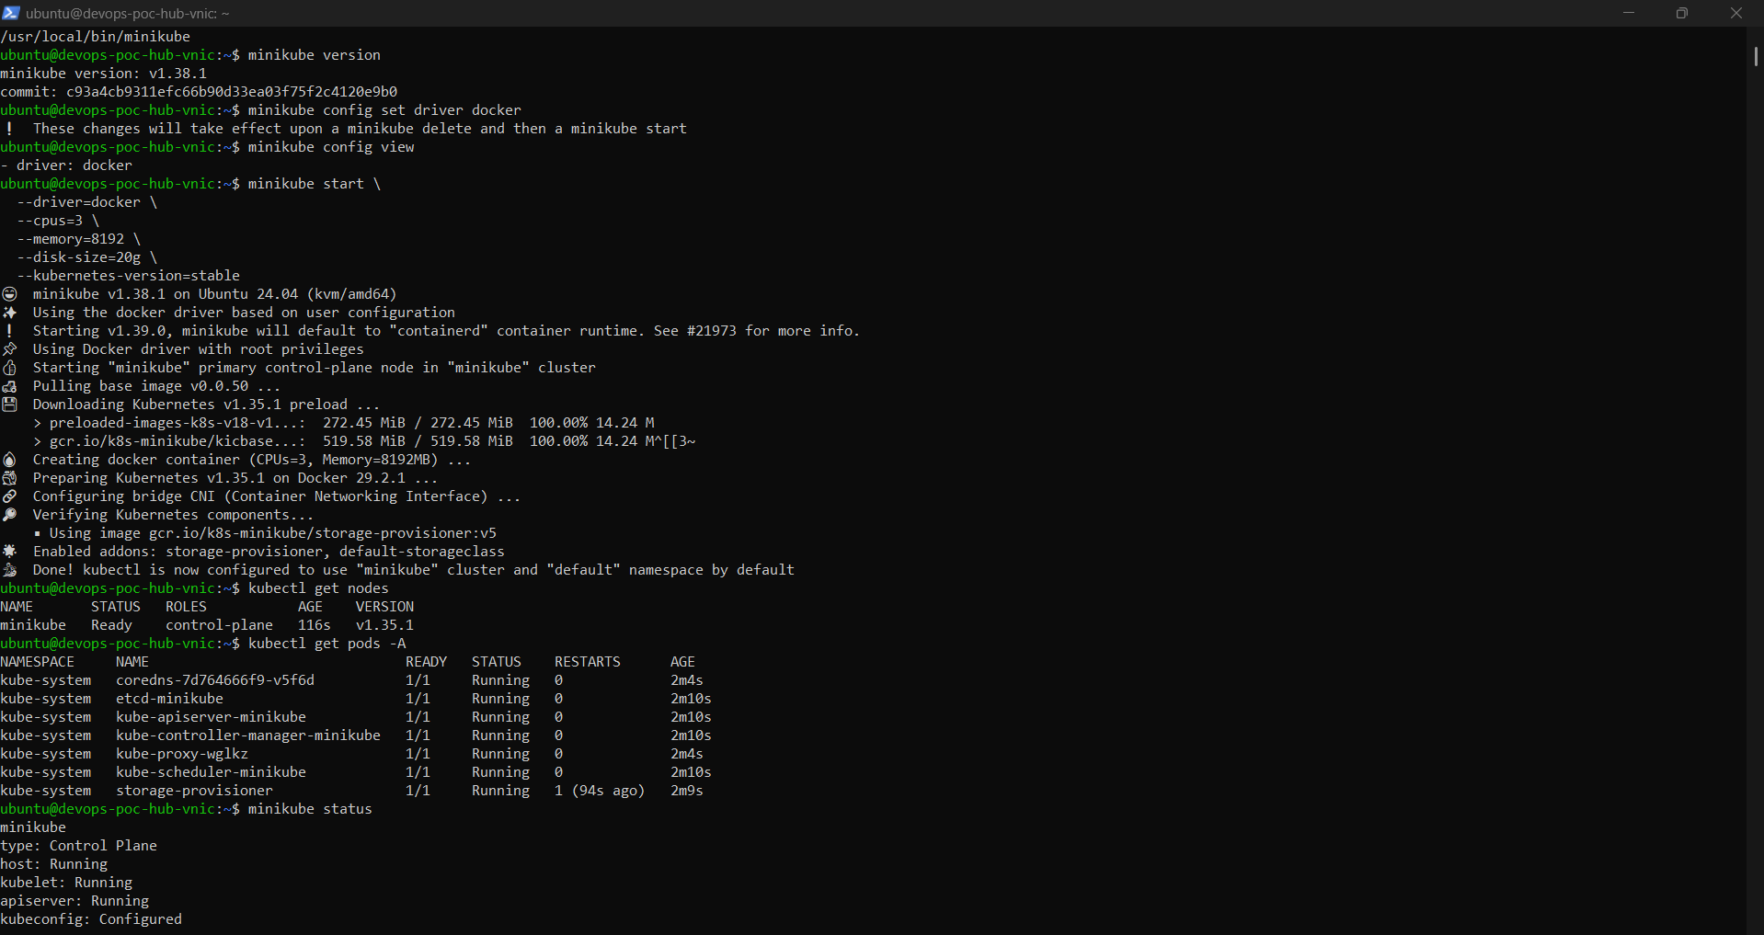
Figure 3.6.1 — Minikube cluster started and verified healthy: node Ready, all system pods Running.
- Applied the Namespace, Deployment, and Service manifests.
- Verified the rollout through replica counts, Pod status, and Service endpoints — not just a clean kubectl apply exit.
- This first deployment became the baseline the automated pipeline in the next phase took over.

3.7 Automated Continuous Deployment
- Gap at this point: a PR merge updated Git, but someone still had to log into the VM, pull manifests, and run kubectl apply by hand — then separately check the rollout succeeded.
- Extended the Jenkins pipeline to deploy to Kubernetes itself, wait for rollout, and verify the result.
- Chose kubectl directly from the Jenkins host over SSH or the Kubernetes plugin — Jenkins, Docker, and kubectl already share the host, so a local call skips an unneeded credential/network hop.
- New stages: Deploy to Kubernetes, Wait for Rollout, Verify Deployment — each isolated so a failure points at a specific cause.
- kubectl apply (idempotent, safe on every merge) followed by kubectl rollout status (fails the pipeline on a broken rollout instead of reporting false success).
- Configured a GitHub webhook so every push to main notifies Jenkins directly, replacing periodic polling with an instant trigger.
git add Jenkinsfile
git commit -m "Automate Kubernetes deployment in Jenkins pipeline"
git push origin feature/cicd-deployment
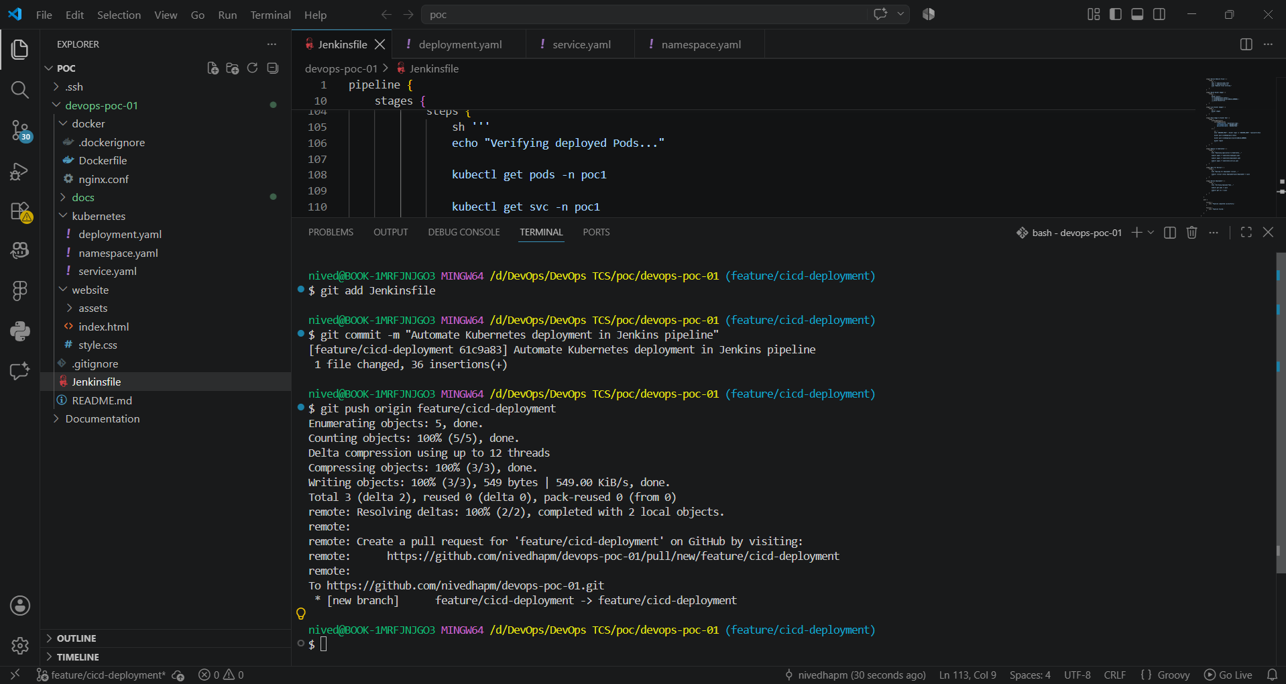
Figure 3.7.1 — Committing and pushing the deploy, rollout-wait, and verification stages added to the Jenkinsfile.
- With the webhook and extended pipeline live, a push to main now triggers the full chain automatically — build, tag, push to Docker Hub, deploy to Kubernetes — no human touches the cluster.
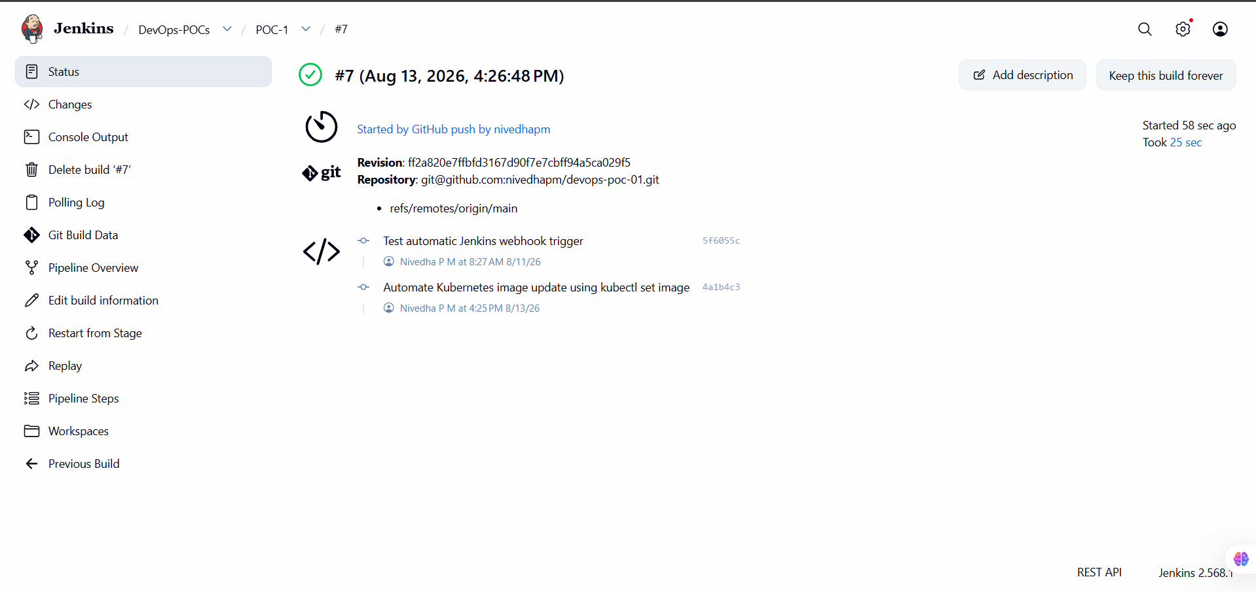
Figure 3.7.2 — Jenkins build #7, triggered automatically by a GitHub push, running the Kubernetes image-update stage.
- Watched the rollout directly on the cluster: new ReplicaSet scaling up, old one scaling down, both replicas Running with zero downtime — a live demonstration of Kubernetes' rolling update behavior, fully pipeline-driven.
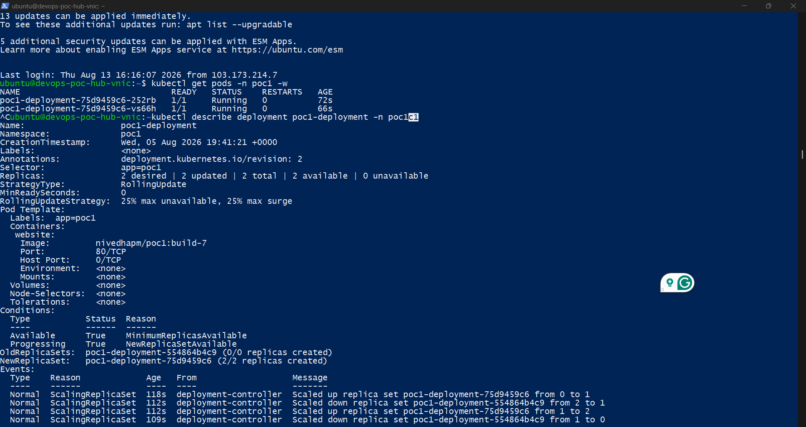
Figure 3.7.3 — kubectl describe deployment confirming a completed rolling update: 2/2 replicas available, old ReplicaSet scaled to zero.
- Reviewed, merged, and cleaned up the feature branch, closing out the phase.
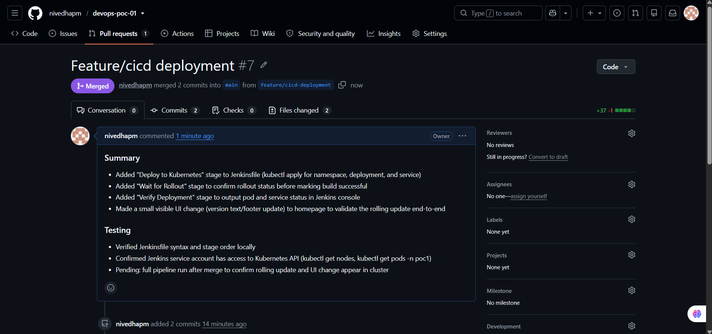
Figure 3.7.4 — Pull Request “Feature/cicd deployment” merged into main, closing the automated-deployment feature.

3.8 Public Access via NGINX Ingress
- Every prior phase accessed the app from inside the cluster's own network — a curl from the Minikube host, or a NodePort reachable only internally.
- This phase closed the last gap: reaching the app from the public internet, through the VM's public IP, the way a real deployment would be accessed.
- Most deceptive part of the project: every layer (Kubernetes, Ingress controller, NGINX) worked correctly in isolation — the blocker was found only by testing each hop independently.
- Chain tested hop by hop: NGINX Ingress Controller → Service, host-level NGINX reverse proxy → Minikube container, and a VM firewall rule that had to be opened and made persistent across reboots.
- Root cause: a Docker-driver Minikube install is not reachable at 127.0.0.1 from its own host VM — the host NGINX config had to route around that.
- Fix: Ingress routes to the existing Service, host NGINX points at the correct Minikube container IP, port 80 opened and made persistent in the firewall.
- Result: the app is reachable at the VM's public IP with no port number and no internal address needed — the original goal of the manager's requirement.
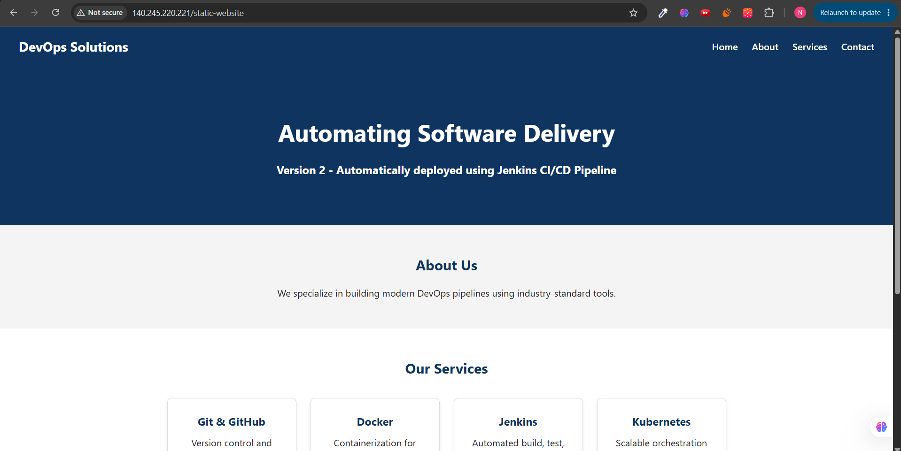
Figure 3.8.1 — The DevOps Solutions website, publicly reachable at the VM's public IP, showing the version deployed automatically by the Jenkins pipeline.
- This is the end of the success chain from the start of the project: a developer push, flowing untouched through GitHub, GitHub Actions, Jenkins, Docker Hub, and Kubernetes, resulting in a live, publicly browsable website.

4. Verification & Results
The success criteria (Section 1.3) required the entire chain — push, validate, build, publish, deploy, verify — to run end to end without manual intervention:
Stage | Status | Evidence
Developer push to GitHub | Automated | Sections 3.1–3.3 (feature branches, PRs, merges)
GitHub Actions validation & Jenkins trigger | Automated | Section 3.4; Figure 3.7.1 (webhook)
Jenkins checkout & Docker build | Automated | Figure 3.4.3
Push to Docker Hub (versioned) | Automated | Figure 3.5.3
Deploy to Kubernetes | Automated | Figure 3.7.2
Rollout wait & verification | Automated | Figure 3.7.3 (2/2 replicas available)
Website publicly reachable | Verified | Figure 3.8.1
- Every stage above completed with no manual step between a git push and the final live website — the success criterion was met in full.

4.1 Deliverables Recap
Deliverable | Status
GitHub repository (devops-poc-01) | Complete — 9 feature branches, all merged via PR
Jenkins pipeline (declarative Jenkinsfile) | Complete — checkout, build, tag, push, deploy, verify
Docker image (NGINX-based) | Complete — devops-poc-01 / nivedhapm/poc1
Docker Hub repository | Complete — versioned with 'latest' + build-numbered tags
Kubernetes Deployment (2 replicas) | Complete — rolling updates verified
Kubernetes Service | Complete — NodePort, later fronted by Ingress
Public, browser-accessible website | Complete — reachable at the VM's public IP
Complete workflow documentation | Complete — this report, phase by phase

5. Conclusion
- POC-1 set out to demonstrate a complete, end-to-end CI/CD pipeline for a static website — Git, GitHub, GitHub Actions, Jenkins, Docker, Docker Hub, Kubernetes, NGINX — documented in enough detail that the reasoning behind every decision is as visible as the implementation.
- Success criteria met in full: a developer push now flows, untouched by human hands, through validation, build, registry publishing, and deployment, resulting in a live, publicly reachable website with zero-downtime rolling updates.
- Every feature was developed on its own branch, reviewed via Pull Request, and merged into main — a clean, auditable history alongside a working pipeline.
- The public-access phase, in particular, demonstrates production-minded debugging discipline: a real multi-hop networking problem diagnosed methodically rather than guessed at.
- With this POC complete, the pattern it establishes — feature branch → PR → automated build → automated deploy → automated verification — is ready to reuse as the template for the remaining POCs on the same DevOps platform.

